**DESIGN AN LED FLASHER**

# **LED Flasher Diagram:**

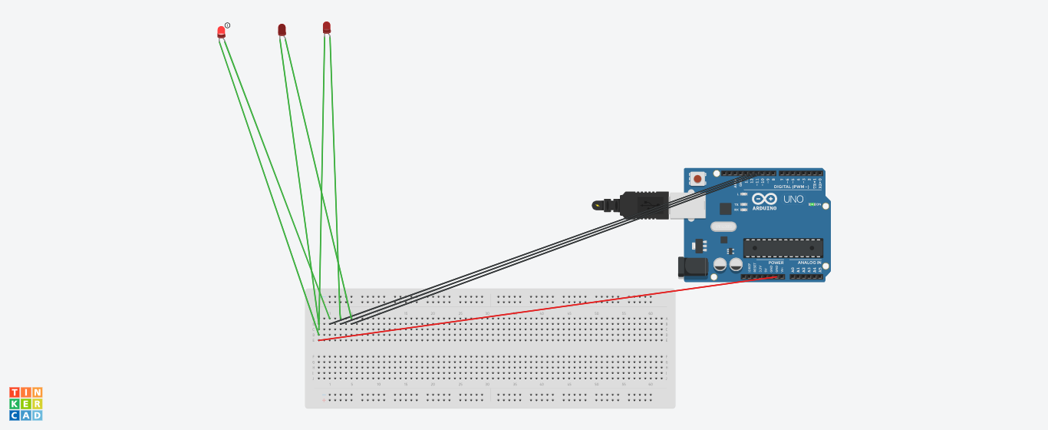

**Theory:**

**CONCEPT USED:**

➢ By using kirchoff’s voltage law &

➢ By using kirchoff’s current law

**LEARNING AND OBSERVATIONS**:

• Connections in Breadboard and wiring.

• How to control arduino and its coding.

•Use of multimeter for continuity.

**OBSERVATION:**

➢ Blinking of an LED.

➢ Relation between software and hardware.

**PROBLEMS & TROUBLESHOOTING:**

o To select the right port and type of arduino

o To check the loose connections

o To check the connections according to the codes

o To check the continuity of the circuit

o To check the flow of current in the circuit

**PRECAUTIONS:**

o Handle tools carefully

o Wear gloves

o Do not connect arduino till the circuit is complete

**OUTCOMES:**

o On and off of an LED

o Used in project works